Unit 7 – Lesson 6. How do we solve the dishonest casino problems – Part 2

Aim: What is Hidden Markov Model?

Objectives: After the lesson, students should be able to:
- Obtain understanding of Hidden Markov property and HMM
- Explain Hidden Markov chain using examples

References:
- CMU, Machine Learning

CLASS PROCEDURE:
Do Now: Recall yesterday, we did the following calculation to calculate the probability of using a loaded die when we get three sixes.

Based upon the Bayes rule, the probability for getting three sixes:
  - P( 3 sixes | loaded die) = 0.5 * 0.5 * 0.5
  - P (loaded die) = 0.05 [Given: 5% chance for switching dices]
  - P(3 sixes) = P(3 sixes | Loaded Die) P (Loaded Die) + P(3 sixes | Fair Die) P (Fair Die)

As per the Bayes rule:

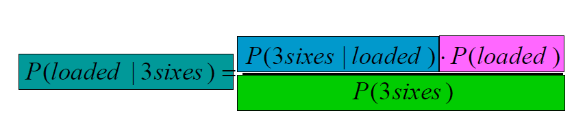

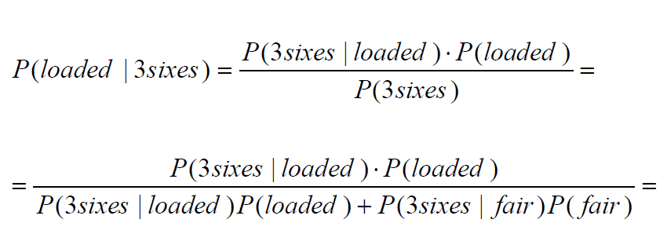
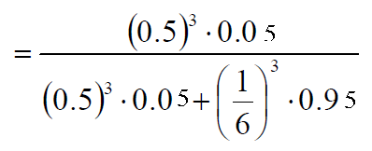

= ???

Class Discussion / Presentation:
- Modify the problem:

Let’s assume an dishonest casino that doesn’t switch dice very often. Let’s assume 99% of the time they use the fair die, and they only switch for 1% probability.

- Fair die: Prob(1) = Prob(2) = . . . = Prob(6) = 1/6
- Loaded die: Prob(1) = Prob(2) = . . . = Prob(5) = 1/10, Prob(6) = ½
- These are the emission probabilities

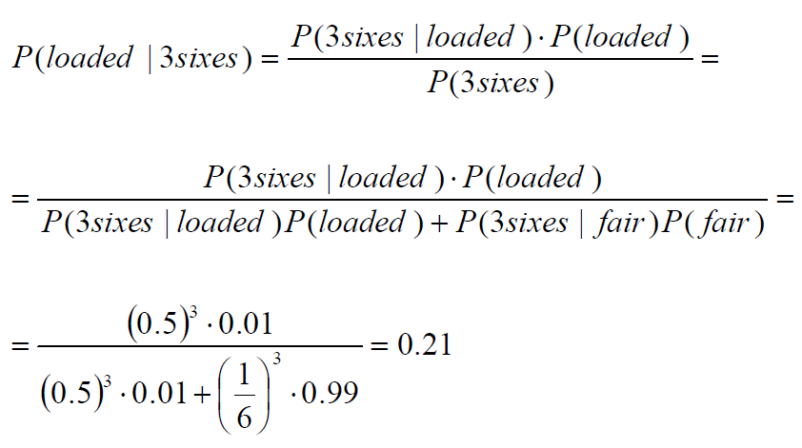

- Prob(Fair → Loaded) = 0.01
- Prob(Loaded → Fair) = 0.2
- Transitions between states obey a Markov process

- The probability of using the loaded is 0.2, and therefore, we have the transition probabilities as well as the transition state diagram:

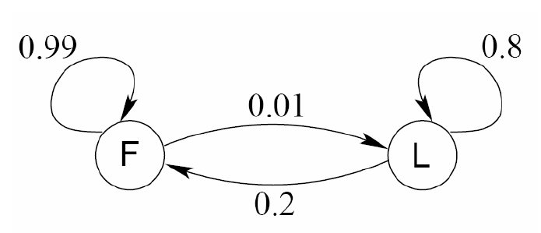

- To summarize the HMM problem given:

• Known:
– The structure of the model
– The transition probabilities

• Hidden: What the casino did
– FFFFFLLLLLLLFFFF...

• Observable: The series of die tosses
– 3415256664666153...
• What we must infer:
– When was a fair die used?
– When was a loaded one used?

• The answer is a sequence
FFFFFFFLLLLLLFFF...

- Making the inference

• Model assigns a probability to each explanation of the observation:

Example, if the series of the die tosses start with 326, then:

P(326|FFL)
= P(3|F)·P(F→F)·P(2|F)·P(F→L)·P(6|L)
= 1/6 · 0.99 · 1/6 · 0.01 · ½

• Maximum Likelihood: Determine which explanation is most likely
– Find the path most likely to have produced the observed Sequence

• Total probability: Determine probability that observed sequence was produced by the HMM
– Consider all paths that could have produced the observed sequence

Now, we need to introduce some new notation to describe the PATH.

New notation

• x is the sequence of symbols emitted by model
– xi is the symbol emitted at time i

• A path, π, is a sequence of states
– The i-th state in π is πi

• a_{kr} is the probability of making a transition from state k to state r:
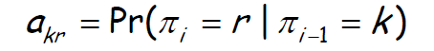

• ek(b) is the probability that symbol b is emitted when in state k
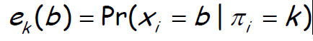

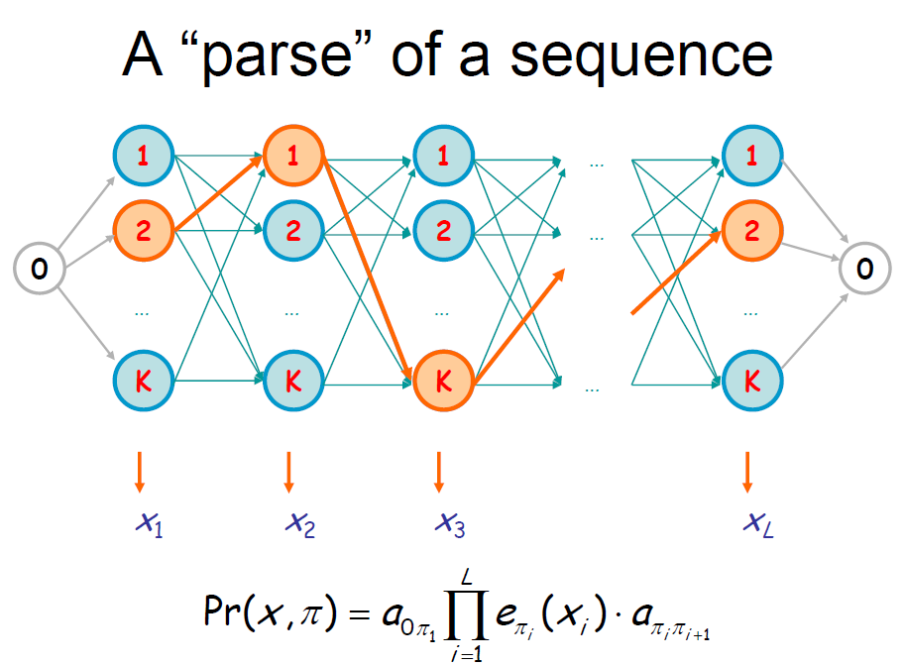

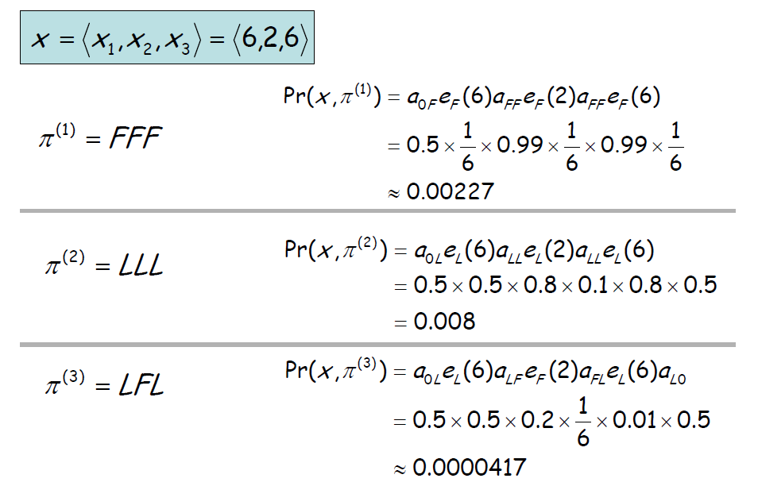

Now, how do we use the new notations to find the most probable path???

